


AGREEMENT LETTER FOR THESIS PROPOSAL DEFENSE

This is an agreement between the Department of Computer, Information Sciences and Mathematics and the undersigned proponents of the thesis proposal entitled Addressing Typographic Hallucination in Generative AI Images: An Open-Set Metric Learning Approach to Font Style.
The undersigned agrees to submit the following:
1. 3 complete copies of thesis/capstone proposal document; and
2. 1 copy of sworn and recommendation letter.
These are to be submitted on July 27, 2026, before 5:00 PM at the department office.
Failure to do so will automatically earn the proponents a grade of 5.0 for the CS3201N - Thesis Proposal this semester.

Signed this 22nd day of July, 2026.



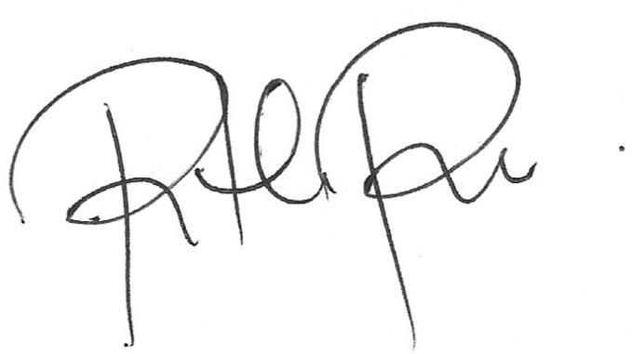
Matt Erron Cabarrubias Maria Monaliza G. Cabarrubias

Student Guardian

Janritch Diputado Ritchie Diputado
Student Guardian

Mrs. Christine D. Bandalan, MEng
Thesis Proposal Adviser

